NAME_________________________________ PERIOD_______ SCORE_______ Unit 6 Review N

1. Use the grid below to draw and label  with the length of  7 units, the length of  9 units, and the measure of  = .

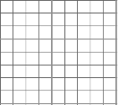

1. What is the area of the triangle in #1? Justify your answer.
2. Determine if the given angles will make a triangle. Explain why or why not. 32**°**, 102**°**, 37**°**
3. Determine if the given angles will make a triangle. Explain why or why not. Angles 15**°**, 70**°**, 95**°**
4. Find the measure of an angle whose complement is 40°.
5. 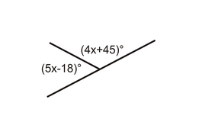Find the measure of an angle whose supplement is 151°.

6x -15

1. Find the value of *x*:

In the diagram below, $∠ADB$ is a right angle. 3 intersecting lines form the figure.

Fill in the measures and justifications in the table:

|  |  |  |  |
| --- | --- | --- | --- |
| **Angle** | **Measure** | **Justification** | 27 degrees |
| $$∠CDA$$ | $$90°$$ | Supplementary to $∠ADB,$ which is 90. |
| $∠ADG$ 8. |  |  |
| $∠GDB$ 9. |  |  |
| $∠BDF$ 10. |  |  |
| $∠EDC$ 11. |  |  |

1. 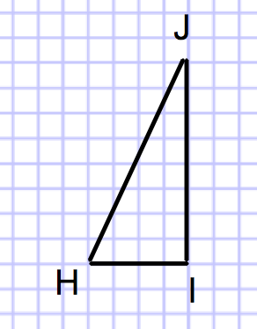If the ratio of  to  is , (see below), draw . Find the length of sides DE and EF.

$$\frac{4}{2}$$

1. The ratio of  to  is 5:3. If  is 15, what is the length of  ? You may need to draw a diagram.
2. The triangles given are proportional. Do the following: a) solve for the unknowns by using proportions and b) state the scale factor between the two triangles. Express all answers exactly. Figures are not necessarily drawn to scale. Show your work.

5

9

x

8

y

16

3

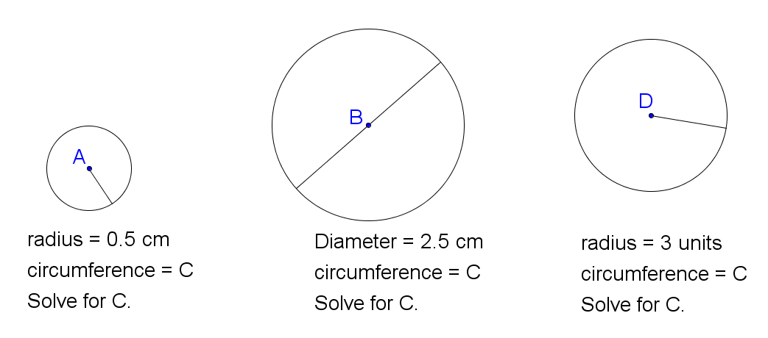For each of the circles below, calculate the circumference of the circle. Express your answer both in terms of π, and also as an approximation to the nearest tenth. *Please note: drawing is not to scale.*

17.

16.

15.

5 units

3.5 cm

3 cm

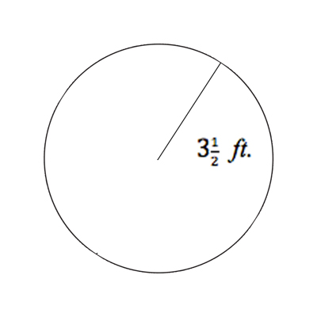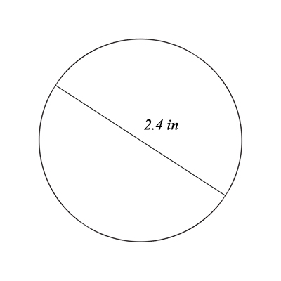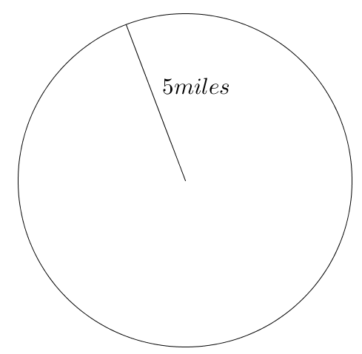Calculate the area of each circle. Express your answer both exactly (in terms of pi) and approximately, to the nearest tenth of a unit.

15 mi

19.

20.

18.

5 in

NAME_________________________________ PERIOD_______ SCORE_______ Unit 6 Review H

1. Use the grid below to draw and label  with the length of  6 units, the length of  3 units, and the measure of $<ABC=90°$



1. What is the area of the triangle in #1? Justify your answer.
2. Determine if the given angles will make a triangle. Explain why or why not. 35**°**, 97**°**, 43**°**
3. Determine if the given angles will make a triangle. Explain why or why not. Angles 22**°**, 82**°**, 76**°**
4. Find the measure of an angle whose complement is 64°.
5. Find the measure of an angle whose supplement is 76°.
6. Find the value of *x*:

(3x – 7)

(2x + 6)

In the diagram below, $∠AHE$ is a 101º angle. 3 intersecting lines form the figure.

Fill in the measures and justifications in the table:

|  |  |  |  |
| --- | --- | --- | --- |
| **Angle** | **Measure** | **Justification** | 71º  H  E  G  D  C  B  A |
| $∠GHE$ 8. |  |  |
| $∠EHD$ 10.  9. |  |  |
| $$∠CHD$$ |  |  |
| $∠BHA$ 11. |  |  |

1. If the ratio of  to  is $\frac{3}{2}$ (see below), draw . Find the length of sides DE and DF.

J

I

H

1. The ratio of  to  is 7:3. If  is 21, what is the length of  ? You may need to draw a diagram.
2. The triangles given are proportional. Do the following: a) solve for the unknowns by using proportions and b) state the scale factor between the two triangles. Express all answers exactly. Figures are not necessarily drawn to scale. Show your work.

12

y

7

x

18

10

For each of the circles below, calculate the circumference of the circle. Express your answer both in terms of π, and also as an approximation to the nearest tenth. *Please note: drawing is not to scale*

15. 16. 17.

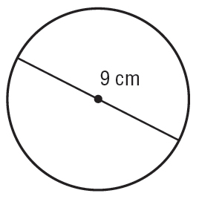 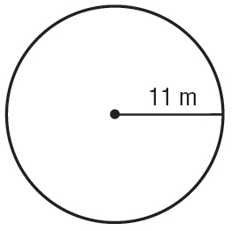 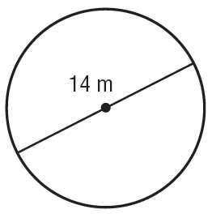

Calculate the area of each circle. Express your answer both exactly (in terms of pi) and approximately. 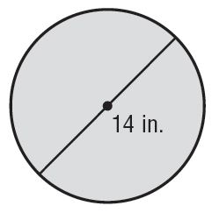 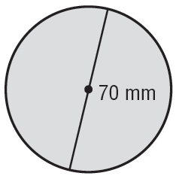 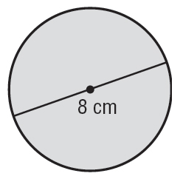

19.

20.

18.